Corporate Office
Flex Air Solutions
P O Box 64
Friendswood TX 77549

Phone
281.332.8797

Fax
281.526.2501

Toll Free
866.771.3065

Project Inquiry
inquiry@flexairsolutions.com

Sales Manager
steveg@flexairsolutions.com

If you have a specific requirement, please complete the project inquiry form and we will contact you immediately to discuss your project.

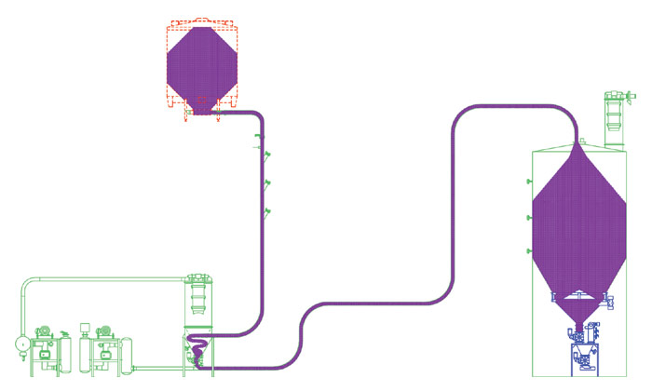

** Mary: Kill the standard blurb at the bottom of the page

