
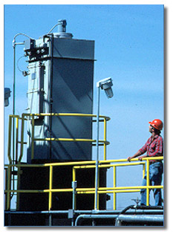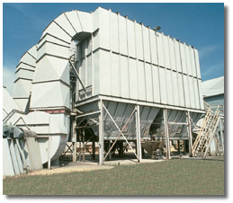
Flex-Air Solutions is the Texas Representative for Flex-Kleen Process Filtration Equipment.
Our company has 20 years of experience designing dust control system for a variety of applications.
Flex-Kleen, a division of Met-Pro Corporation, is America's #1 dust collector supplier. Flex-Kleen provides dry particulate dust collection systems for process dust control, product recovery, nuisance dust collection and air pollution control.
Major products include bin vent filters, welded modules, high-pressure and high vacuum pulse-jet dust collectors, high efficiency cartridge and pleated element filters and cyclones.
Major Markets  - Cement & rock products  - Chemical & petrochemical  - Coal & fly ash  - Food & dairy  - Minerals & clay  - Oil refining  - Paint and pigments  - Plastics  - Pharmaceutical | Primary Products  - Dry particulate dust collecting systems  - Bin vent filters  - Welded modules  - High-pressure/high vacuum dust collectors  - Cartridge & pleated element dust collectors  - Cyclones

For additional information on Flex-Kleen products, please visit the Flex-Kleen website at www.flex-kleen.com

