
Bulk Material Handling Equipment
Hapman has the right equipment and/or systems to successfully convey your bulk materials – whether wet or dry – hot or cold.
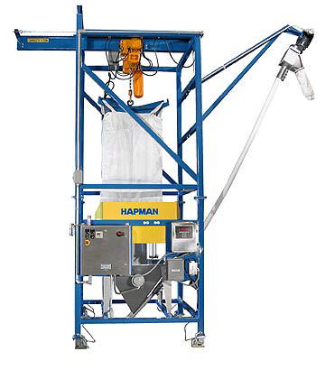
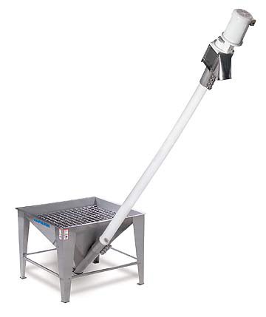
Helix™ Flexible Screw Conveyors
Bulk Bag Unloaders
Provides numerous features to allow complete and safe control over your bag loading operation. Options include total dust control, bag agitation, lump breaking and extremely accurate batch weigh systems. Forklift or trolley bag loading.
Ideal for transferring finely divided free-flowing bulk materials over distances up to 40 ft. with capacity up to 1500 CFH. 2” – 8” sizes. Features simple maintenance with only one moving part. Carbon/stainless and polyethylene. Standard, Sanitary, FDA, USDA and 3A Dairy Finishes available.

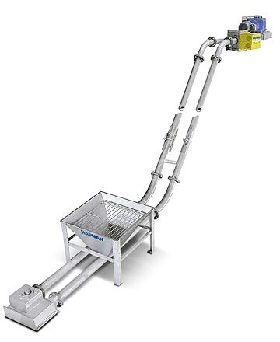
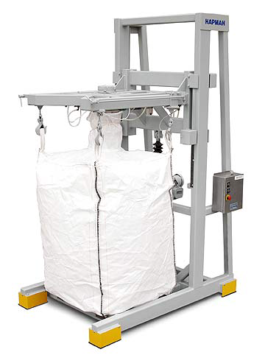
Tubular Drag Conveyors
Cantilevered Bulk Bag Fillers
This fully enclosed system efficiently and gently moves even the most tenacious material (dry, wet, hot or cold). Allows multiple inlet and discharge ports, comes in a choice of flight materials, from 3” to 10” diameter. A diverse selection of layout configurations are available to meet most applications.
Easy access filler provides numerous features to allow complete and safe control over your bag filling operation. These features include guarded weigh sensors, motorized bag lifting/lowering, venture bag liner pre-inflator/de-aerator, traversing rear hook release, bag agitation plus much more. Choice of standard conveyor feed or adapted for drum filling.

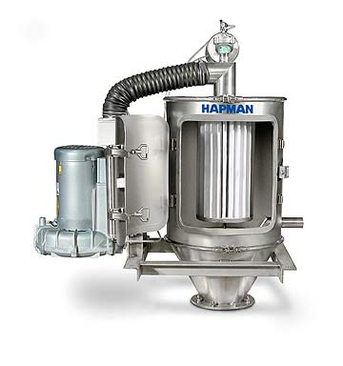
MiniVac™ Pneumatic Conveyors

Ultra compact and efficient unit fits in where others won’t. Features an easily maintained cartridge filter system with a reverse air pulse system to maintain efficient, continuous operation. Can be easily integrated with processing equipment and into just about any plant layout. Standard, Sanitary, FDA and USDA finishes are available.
PosiPortion™ Feeders

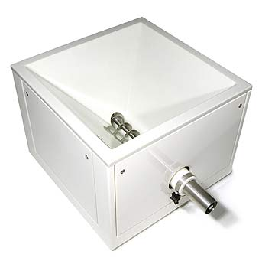
External agitation of flexible polyurethane hopper walls assures consistent flooding of the dosing screw, without agglomeration, segregation or degradation. This same feature makes it easier to clean, change over and maintain. Solid steel tube frame construction provides stable platform capable of supporting refill equipment. PLC based open architecture controls makes commissioning easy and eliminates time spent waiting for costly proprietary hardware, if replacement parts are needed.

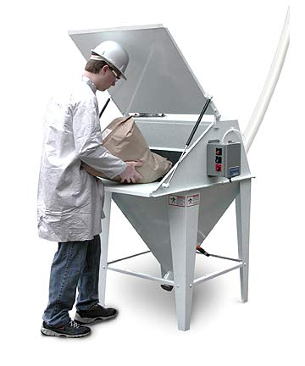
Bag Dump Stations

Internal cartridge filtration system keeps dust, generated during dumping, confined within the process. Automatic, reverse air-pulse keeps material build-up off filters to allow maximum operation efficiency. Available with integral bag compactor for better housekeeping. May be equipment or hopper mounted with hoppers / options tailored to your needs.

For additional information visit the HAPMAN website at www.hapman.com.

