*HOME * LINES REPRESENTED * JOB PHOTOS *CONTACT US
__________________________________________

Process Filtration, Conveying & Control Systems

Flex Air Solutions is a manufacturer’s representative agency serving the State of Texas in the bulk material handling and pollution control markets.

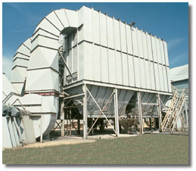

INDUSTRIES SERVED

- Plastics production and processing
- Chemicals
- Food
- Wood and building materials
- Cement
- Power Generation
- Minerals and mining

OUR STAFF

Flex Air Solutions has outside sales personnel in Houston, Dallas and South Texas.
Our qualified staff has many years experience in designing industrial ventilation systems and bulk material conveying systems.

We are a “Solution”- oriented company. We incorporate our principles’ equipment to provide value-added solutions for our customers and their material handling and pollution control applications. Turnkey installation services are also available.

Contact our sales office today to discuss your specific needs.

EXCLUSIVE MANUFACTURERS REPRESENTED

“As Is”

