Horizon Systems manufactures material handling equipment for the most demanding applications; including:
- Batch Dense Phase
- ConTran Continuous Dense Phase
- Strand Conveying
- Dilute Phase Transfer - Pressure and Vacuum
- Dense Phase Transfer - Pressure and Vacuum
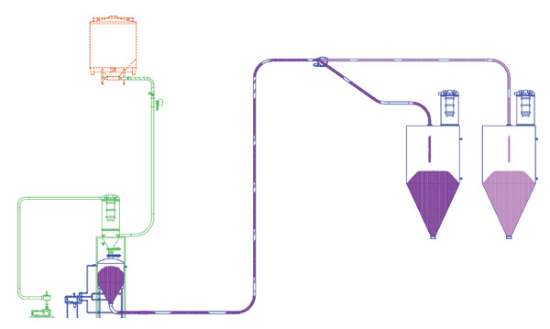

DENSE PHASE PRESSURE SYSTEM

Horizon Systems has a state-of-the-art test lab facility to test specific characteristics of your materials under simulated operating conditions. These tests are conducted with low-to-high pressure conveying air, at low velocity, in continuous dense phase flow.
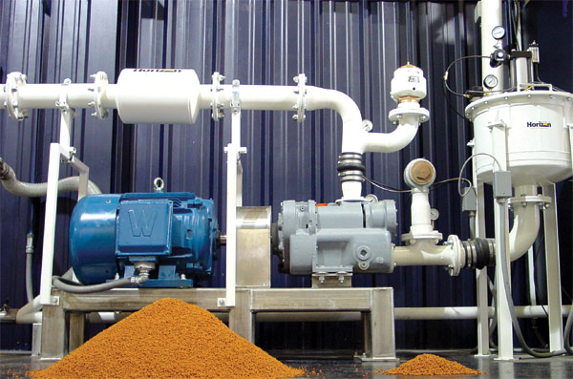

Flex Air Solutions can assist you in selecting the best approach for your material conveying requirements and can provide turn-key installation of silos, conveying systems, process filtration, automation controls and start-up to get you materials moving.

