

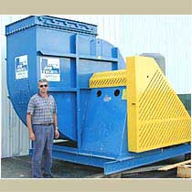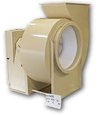

Industrial Air Technology manufacturers a broad range of industrial air handlers.

BISW, BIDW Backward Inclined
IRO, IRW, IRB and IRT Industrial Exhauster Series
RTS Radially Tipped
BCLS Backward Curved High Pressure Industrial Blower
TROL, TROH High Pressure Industrial Blowers
Industrial Plug Fans

DESIGN FEATURES INCLUDE:

- Standard and Custom designs
- Clean Air Ventilation
- Material Handling
- Corrosive Gasses
- Alloy Construction
- Spark resistant / explosion proof
- Special coatings and lining
- Temperatures to 1200 degree F
- Flows to 400,000 cfm
- Static pressure to 120” w.c.
- 12” – 120” wheels

For additional information you may visit Industrial Air Technology’s website at www.indairtech.com

Flex Air Contact Info Here.

Return to home page

