

NAVCO manufactures industrial vibratory flow aids designed to assist in the handling, processing and packaging of dry bulk solid materials.

Industries Serves include Foods, Petroleum and Coal, Pharmaceuticals, Waste/Recycling, Grain, Aggregates,
Ceramics, Plastics, Cement, Rubber, Glass and Steel.

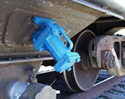
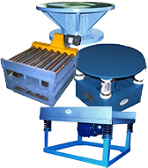
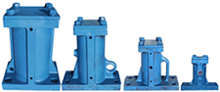
Bin Hopper Vibrators
Available in (8) sizes to keep materials
moving in bins or hoppers.

Rail Car Shakers

Rail Side Car shakers, Overhead
Car Shakers and Portable Railcar
Shakers designed for loading and
unloading of rail cars.

Vibratory Tables
Grid Top, Jolt Top and Flat Top
Used for packaging / densification and
vibratory fatigue testing. Available with
pneumatic or electro-mechanical drives.

For additional information visit the NAVCO website at www.navco.org

